**PIZZA SALES SQL QUERIES**

1. **KPI’s (Key Performance Indicators)**
2. **Total Revenue**

select SUM(total_price) as Total_Revenue from pizza_sales

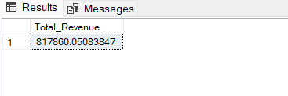

1. **Total Order Value**

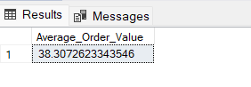select Sum(total_price)/count(distinct order_id) as Average_Order_Value from pizza_sales

1. **Total Pizzas Sold**

select sum(quantity) as Total_Pizzas_Sold from pizza_sales

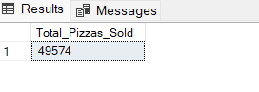

1. **Total Orders**

select count(distinct order_id) as Total_orders from pizza_sales;

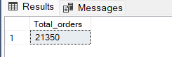

1. **Average Pizzas per Order**

select CAST(sum(quantity) AS decimal(10,2)) / CAST(count(distinct order_id) AS decimal(10,2)) as Average_Pizzas_Per_Order from pizza_sales;

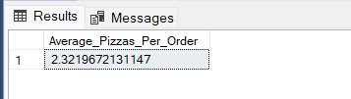

1. **Chart Requirements**
2. **Daily trends for total orders**

select DATENAME(dw, order_date) as Order_Day, COUNT(distinct order_id) as Total_orders from pizza_sales group by DATENAME(dw, order_date);

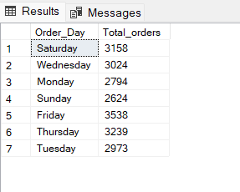

1. **Monthly Trend for total orders**

select DATENAME(month, order_date) as Order_Month, COUNT(distinct order_id) as Total_orders from pizza_sales group by DATENAME(month, order_date) order by Total_orders desc;

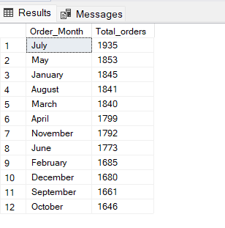

1. **Percentage of Sales by Pizza Category**

select pizza_category,sum(total_price) as Total_sales, sum(total_price) *100 / (select sum(total_price) from pizza_sales) as Total_sales_percentage from pizza_sales group by pizza_category;

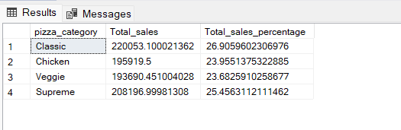

**(In case we want to see percentage of sales in the month of January)**

select pizza_category,sum(total_price) as Total_sales, sum(total_price) *100 / (select sum(total_price) from pizza_sales where MONTH(order_date)=1) as Total_sales_percentage from pizza_sales where MONTH(order_date)=1 group by pizza_category;

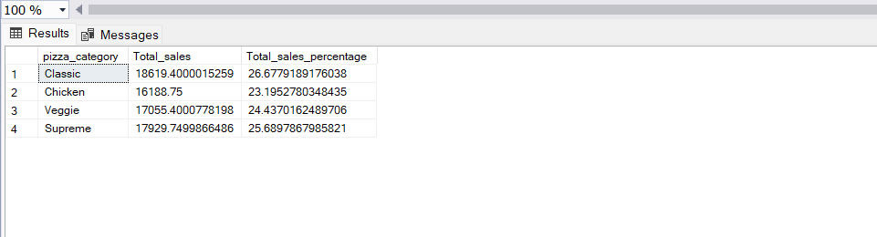

1. **Percentage of Sales by Pizza size**

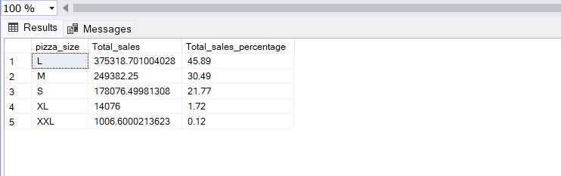select pizza_size,sum(total_price) as Total_sales, cast(sum(total_price) *100 / (select sum(total_price) from pizza_sales) as decimal(10,2)) as Total_sales_percentage from pizza_sales group by pizza_size order by Total_sales_percentage desc;

1. **Top 5 best sellers by revenue**

select top 5 pizza_name, sum(total_price) as Total_Revenue from pizza_sales group by pizza_name order by Total_Revenue desc

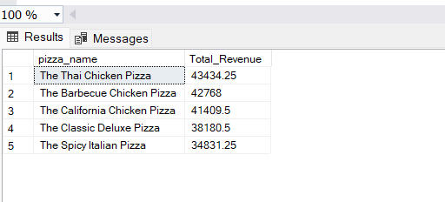

1. **Bottom 5 best sellers by revenue, total quantity and total orders**

select top 5 pizza_name, sum(total_price) as Total_Revenue from pizza_sales group by pizza_name order by Total_Revenue

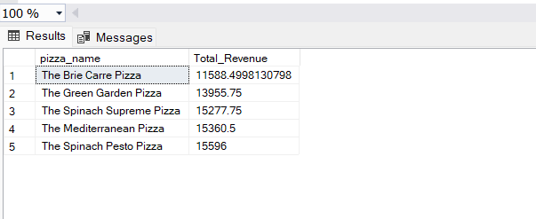

1. **Top 5 best sellers by quantity**

select top 5 pizza_name, sum(quantity) as Total_Quantity from pizza_sales group by pizza_name order by Total_Quantity desc

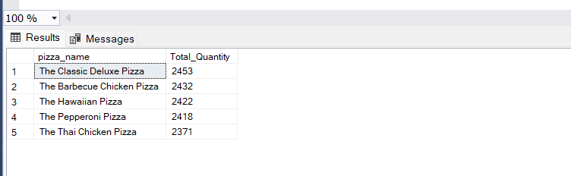

1. **Bottom 5 best sellers by quantity**

select top 5 pizza_name, sum(quantity) as Total_Quantity from pizza_sales group by pizza_name order by Total_Quantity

